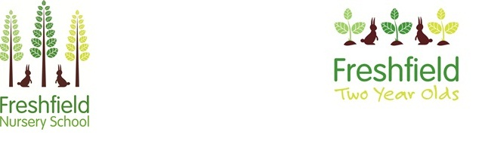

**Newsletter**

**December 2021**



**How are we in December already? What a term we have had! We have so enjoyed getting to know you and your children this term. We know this is going to be a fantastic year!**

**School closes on Tuesday 21st December for the holidays and re-opens on Thursday 6th January.**

**We hope you all have a wonderful Christmas and a Happy New Year.**

**Thank you for your ongoing support.**

**Mrs Jenny Martin, Mrs Kat Walsh (Co-Headteachers) and the Freshfield Nursery Team.**

December is a very busy month here at Freshfield! We have lots of special days and events lined up for you and the children. An ‘Event List’ document should have been sent to you alongside this newsletter to inform you of all of these important dates.

**Nativity days –** Please remember to bring in costumes – you will receive a letter about this. Our special performances will be uploaded on to Tapestry.

**Make and Bake days –** There is so much fun to be had on these days! Lots of yummy and crafty things to buy and a chocolate tombola! Come along and have a hot chocolate with us!

**Christmas Jumper day –** Wear your favourite Christmas jumper and don’t forget to bring in your donation for our chocolate tombola!

**Festive fires at Nature School –** Look out for Tapestry updates ☺

**Allergies**

We ask that you choose foods other than nuts (including peanuts), eggs, fish or shellfish to go in your child’s lunchbox. Thank you for your support with this.

**Contact Details**

**Nature School and Risky Play**

The children are already making fires and cooking food in Nature School. They are so sensible and excellent at remembering our rules. We can’t wait to continue these sessions in the New Year!

We have a new risky play policy which you can find on our website alongside information about the benefits of risky play, and how we manage it at our nursery.



admin@freshfield.stockport.sch.uk

**0161 442 6944**

**A Christmas message from Danielle Vessey (Chair of Governors)**

Christmas greetings to you all. Firstly, I would like to introduce myself as the new Chair of Governors. I have been a governor with Freshfield for over 6 years and have enjoyed every minute of being involved with the nursery and I’m sure I will continue to do so. Both my daughters, who are 9 & 6 attended the nursery, as did I many moons ago. So it holds very special memories with me.

On behalf of the Governors and myself I would like to take this opportunity to thank Jill Jones, our previous Chair, who has been committed to Freshfield for over 6 years. Jill has given her time and commitment to the nursery and we are extremely grateful to her. Luckily for us she is staying on the board of governors, so we can still use her expertise. Thank you Jill for all your hard work.

I’d like to continue my thanks to all the staff for all of their continued support & hard work to the school, especially during these difficult times over the last 18 months. We are truly thankful to have such commitment & loyalty within the school.

My final thanks is to all of the parents, careers and children who continue to support our school.

Finally, on behalf of all the governors, I wish you all a very Merry Christmas & a Happy New Year.

All the very best and kind regards, Danielle Vessey

We would also like to welcome as our new Parent Governor.

**School Fund**

A huge thank you to everyone that has already contributed to our school fund.





We hope you are enjoying seeing your children’s WOW moments and trips to nature school! We love seeing what you’ve been up to at home too, so please keep them coming in.

We request a weekly voluntary contribution of £2.50 to support us to purchase:

A birthday cake and a small gift for your child.

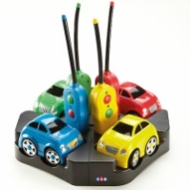

Some special resources for school.

**OPAL – Observation of Play and Learning**

We hope you appreciate the information we have sent out regarding our new approach to assessment. If you have any questions about your child’s development, or wish to find out when their assessment month will be, please speak to your child’s group leader.

**Baby Massage at Freshfield Nursery**

Baby massage has been a great success this half term! We are also fully booked for our January course! If you

would like any more

information for future courses

please contact the office.

