[](https://www.google.co.uk/url?sa=i&rct=j&q=&esrc=s&source=images&cd=&cad=rja&uact=8&ved=2ahUKEwjPzrfO5-PYAhVFOhQKHaqkAcoQjRx6BAgAEAY&url=https://www.netzerobuildings.co.uk/2016/09/eco-schools-energy-efficient-schools-competition/&psig=AOvVaw1A6NKdsiPFCLBFg2bM_pPV&ust=1516443821089328)**Eco Schools Spring/Summer 2019**

**Litter**

Litter picking

Mr Recycle

**Energy**

Switch off fortnight

Water surface concession

**Biodiversity**

Chicks

Tadpoles – New Pond

Caterpillars

[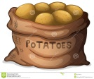](http://www.google.co.uk/url?sa=i&rct=j&q=&esrc=s&source=images&cd=&cad=rja&uact=8&ved=2ahUKEwjlibiIovrgAhUj2eAKHdwgDrsQjRx6BAgBEAU&url=http://worldartsme.com/bag-of-potatoes-clipart.html&psig=AOvVaw1A-AGRM3Qu4BpApFjabsr9&ust=1552399797703119)****[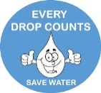](https://www.google.co.uk/url?sa=i&rct=j&q=&esrc=s&source=images&cd=&cad=rja&uact=8&ved=2ahUKEwj9iMvN3uPYAhUCVRQKHZt9B4cQjRx6BAgAEAY&url=https://www.pinterest.co.uk/markamoment/free-cliparts/&psig=AOvVaw3JbZW64IFqMXmgkb4zDJ9p&ust=1516441383529184)[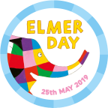](https://www.google.co.uk/url?sa=i&rct=j&q=&esrc=s&source=images&cd=&ved=2ahUKEwiFqf3w_97iAhWryoUKHaVzDzQQjRx6BAgBEAU&url=https://www.elmerday.co.uk/&psig=AOvVaw3n6Q05zmScLOWROYZIyWZn&ust=1560259003658887)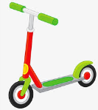 [](https://www.google.co.uk/url?sa=i&rct=j&q=&esrc=s&source=images&cd=&cad=rja&uact=8&ved=2ahUKEwiaj6jI3OPYAhXBXRQKHYnOCm4QjRx6BAgAEAY&url=https://en.wikipedia.org/wiki/Recycling_symbol&psig=AOvVaw1OmtvztWuyOMuCFcpzZmr5&ust=1516440794795568)[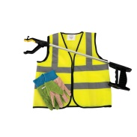](https://www.google.co.uk/url?sa=i&rct=j&q=&esrc=s&source=images&cd=&cad=rja&uact=8&ved=2ahUKEwiHnNf47eHYAhVoLMAKHSYNBe4QjRx6BAgAEAY&url=https://www.educationsupplies.co.uk/children-s-litter-picking-kit&psig=AOvVaw2kBOaMC7OKH7cj8HI7gOdh&ust=1516376684070996)[](http://www.google.co.uk/url?sa=i&rct=j&q=&esrc=s&source=images&cd=&cad=rja&uact=8&ved=2ahUKEwix4aPn3OPYAhWEvhQKHVtqDLYQjRx6BAgAEAY&url=http://www.clipartpanda.com/clipart_images/rf-lightbulb-clipart-3702045&psig=AOvVaw1NdF-jxV6j64xmaUO9t86Q&ust=1516440914795350)[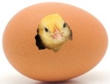](http://www.google.co.uk/url?sa=i&rct=j&q=&esrc=s&source=images&cd=&cad=rja&uact=8&ved=2ahUKEwij7YqD7eHYAhVrLcAKHSvpASsQjRx6BAgAEAY&url=http://raisingchickens.net/hatching-chicken-eggs/&psig=AOvVaw0wIQqbaUaKlVMMqVNQaUSm&ust=1516376552078794)

**Healthy Living**

Grow our own vegetables

Yoga

**School Grounds**

New Planter

Sunflower Planting

**Water**

Using the water shed

Water butt

**Transport**

Encourage children to travel to school by foot, bicycle or scooter

**Waste**

New cardboard recycling bin

Mr Recycle

Recycling lunch box waste

Paper Making

Worm Farm

**Global Citizenship**

Elmer Day –Diversity

Ramadan & EID

Weather Station