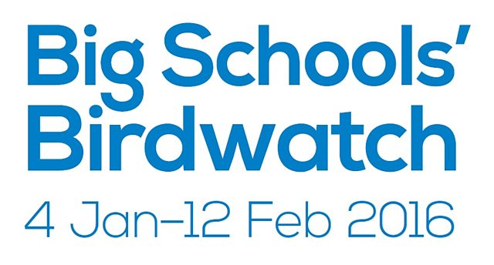
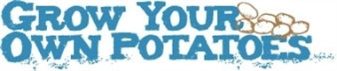
Eco School Spring 2016
Celebrating Chinese New Year
Spring Activity Packs
Food Bank Collection
Dancing with Ailsa
The Big Birdwatch
Grow your own Potatoes Project
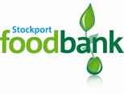
Recycling
