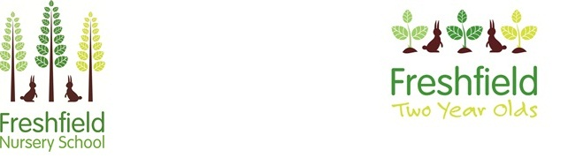

**Newsletter**

**January 2022**

**What a fabulous start to the New Year we have had. Welcome to all of our new families!**

**School closes on Thursday 10th February for the holidays and re-opens on Tuesday 22nd February.**

**Have a lovely half term and we look forward to seeing you after the break.**

**Thank you for your ongoing support.**

**Mrs Jenny Martin, Mrs Kat Walsh (Co-Headteachers) and the Freshfield Nursery Team.**



We always celebrate lots of special days and events at Freshfield.

This half term there has been:

* Chinese New Year – 1st February 2022
* Love who you are, wear what you love! – 10th February 2022
* Children’s Mental Health Week home challenge – 7th to 13th February 2022
* Annual (virtual) Open Day for new families – Friday 11th February

**Allergies**

We ask that you choose foods other than nuts (including peanuts), eggs, fish or shellfish to go in your child’s lunchbox. Thank you for your support with this.

**Contact Details**



admin@freshfield.stockport.sch.uk

**0161 442 6944**

**Co-Headteachers’ working days**

Mrs Martin – Monday, Tuesday and Wednesday AM

Mrs Walsh – Wednesday PM, Thursday and Friday

**OPAL – Observation of Play and Learning**

We hope you appreciate the information we have sent out regarding our new approach to assessment. If you have any questions about your child’s development, or wish to find out when their assessment month will be, please speak to your child’s group leader.

OPAL is an early years assessment system developed by Barnet Early Years Alliance (BEYA), a Federation of three nursery schools in north London. It aims to reduce paperwork, supporting practitioners to observe children without fixed agendas and build in time for quality reflection about children’s learning. More information about the OPAL assessment system can be found here:

<https://beya.org.uk/professional-development/opal/about-opal/>

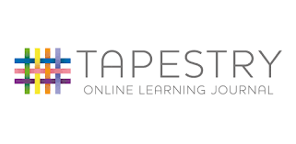

**School Fund**

We hope you are enjoying seeing your children’s WOW moments and trips to nature school! We love seeing what you’ve been up to at home too, so please keep them coming in.



A huge thank you to everyone that has already contributed to our school fund.

We request a weekly voluntary contribution of £2.50 to support us to purchase:

**Baby Massage at Freshfield Nursery**

Baby massage has been a great success again this half term! If you

would like any more

information for future courses

please contact the office.

A birthday cake and a small gift for your child.

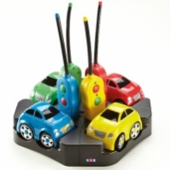

Some special resources for school.

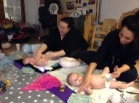

**Social Media**

Please can we send a friendly reminder that mobile phones are NOT permitted for use anywhere on the school premises. Thank you for your understanding.

Don’t forget to follow us on our social media pages! Give us a share!



freshfieldnursery

@freshfieldnursery