[](https://www.google.co.uk/url?sa=i&rct=j&q=&esrc=s&source=images&cd=&cad=rja&uact=8&ved=2ahUKEwjPzrfO5-PYAhVFOhQKHaqkAcoQjRx6BAgAEAY&url=https://www.netzerobuildings.co.uk/2016/09/eco-schools-energy-efficient-schools-competition/&psig=AOvVaw1A6NKdsiPFCLBFg2bM_pPV&ust=1516443821089328)**Eco Schools Spring/Summer 2021**

**Biodiversity**

Pond Project

Tadpoles

Caterpillars

Bee Bath

**Litter**

Litter picking

**Energy**

Switch off fortnight

Water surface concession

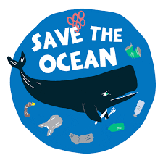[](https://www.google.co.uk/url?sa=i&rct=j&q=&esrc=s&source=images&cd=&cad=rja&uact=8&ved=2ahUKEwiaj6jI3OPYAhXBXRQKHYnOCm4QjRx6BAgAEAY&url=https://en.wikipedia.org/wiki/Recycling_symbol&psig=AOvVaw1OmtvztWuyOMuCFcpzZmr5&ust=1516440794795568)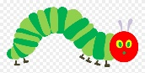[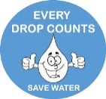](https://www.google.co.uk/url?sa=i&rct=j&q=&esrc=s&source=images&cd=&cad=rja&uact=8&ved=2ahUKEwj9iMvN3uPYAhUCVRQKHZt9B4cQjRx6BAgAEAY&url=https://www.pinterest.co.uk/markamoment/free-cliparts/&psig=AOvVaw3JbZW64IFqMXmgkb4zDJ9p&ust=1516441383529184)[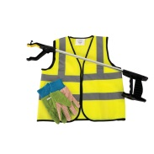](https://www.google.co.uk/url?sa=i&rct=j&q=&esrc=s&source=images&cd=&cad=rja&uact=8&ved=2ahUKEwiHnNf47eHYAhVoLMAKHSYNBe4QjRx6BAgAEAY&url=https://www.educationsupplies.co.uk/children-s-litter-picking-kit&psig=AOvVaw2kBOaMC7OKH7cj8HI7gOdh&ust=1516376684070996)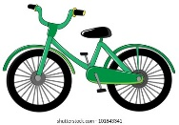**** [](http://www.google.co.uk/url?sa=i&rct=j&q=&esrc=s&source=images&cd=&cad=rja&uact=8&ved=2ahUKEwix4aPn3OPYAhWEvhQKHVtqDLYQjRx6BAgAEAY&url=http://www.clipartpanda.com/clipart_images/rf-lightbulb-clipart-3702045&psig=AOvVaw1NdF-jxV6j64xmaUO9t86Q&ust=1516440914795350)

**Marine**

Taking care of our world group time

Books – Somebody swallowed Stanley

Recycling/Reusing/Reducing Plastic

**Waste**

Recycling lunch box waste

Paper Making

Paper Potter

**Global Citizenship**

Weather Station

Nawruz

Ramadan & EID

**Healthy Living**

Grow our own vegetables

Mental Health Awareness Week

Yoga

**Water**

Using the water shed

Water butt

**Transport**

Sustrans Big Pedal 2021

**School Grounds**

Grow Vegetables

Sunflower Planting